University of Petroleum and Energy Studies
School of Computer Science
Department of Cybernetics

Graphics & Animation Tools
LAB FILE
(Session: 2020-2021)

Course: B. Tech with Specialization in Open Source and Open Standards

Submitted To- Submitted By-
Dr. Durgansh Sharma Rahul Raj Baranwal
Associate Professor SAP ID -500061624
Department of Cybernetics Roll No. -R100217054

Experiment- 8 Design of 3D Car using Blender.
In this experiment we need to create a 3D Car of our choice with the help of blender.
Step-1 Clear your default interface of blender which includes deletion of cube.
Step-2 Go to the mesh and select the image option and set a picture of car as background image in blender.
Step-3 Go to mesh and select a cube and cut this cube in half and now you can use mirror modifier to complete the other half of our car design. With the help of mirror modifier, you can design one side of car and another half will follow accordingly. Also do check clipping mode in mirror modifier.
Step-4 Now extrude the cube in the form of rectangular bar which will act as body for our car and do follow the background picture you used in step-2.
Step-5 Now give the cube the almost exact shape of the central portion of the image.
Step-6 Now go to face select mode and select the upper portion of cube and extrude it a little bit to give it the shape of roof of our car. And extrude from the slide to give it a little slant for more realistic view.
Step-7 Now to design the wheels of our car, go to shapes and partition and put them across our car body and give them a good circular shape in form of a wheel. Select all the sides except the area consisting of wheels. Now go to top view and extrude the whole body sidewise, which will give you a good shape of the body with space for wheels.
Step-8 Now move all the edges a little bit inwards to give a more realistic view to the car. Ad now move the front view of the car in the middle slightly to give it space for headlights.
Step-9 Now look at your background picture and extrude from all sides where you need to provide a great real view accordingly.
Step-10 Now go to central portion of wheel area and go to mesh and select a circle and go to circle setting and change it to 16 vertices and now hit R-90 and select the circle and extrude along x axis to give a real view for the thickness of the tyres.
Step-11 Hit E and scale it down to give the rims of tyre a great real view. Now press s and scale the tyres a little bit outward to give a slight bulge to it. Now select the alternate of 16 vertices and give it a slight extrude and designing for real nice-looking view for tyres.
Step-12 Duplicate the same tyre by pressing, press L and press D to duplicate the tyre and press G and Y to move the front tyre to back side and fix it in the centre.
Step-13 Add review mirrors by extruding the surface of the car side wise and move it towards the driver and tilt it a bit down.
Step-14 Now for the colouring part, go into the edit mode again, and select the faces you want for one colour, and click the + button in the materials section
Step-15 This will apply the colour to all faces, next click on another face, click the + button, and click Assign, this will give the selected face the new material.
Step-16 Finally export your files as .blend file and also render a few images for the reference purpose.

Output (Rendered Pictures for Reference):

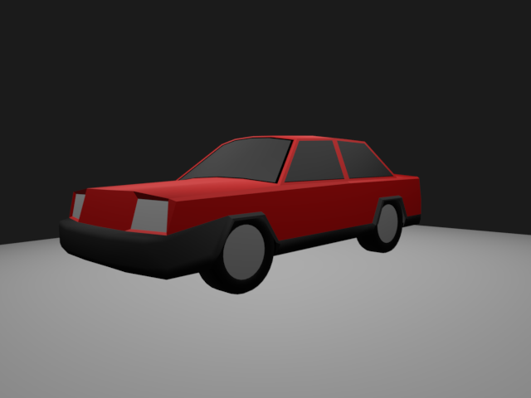
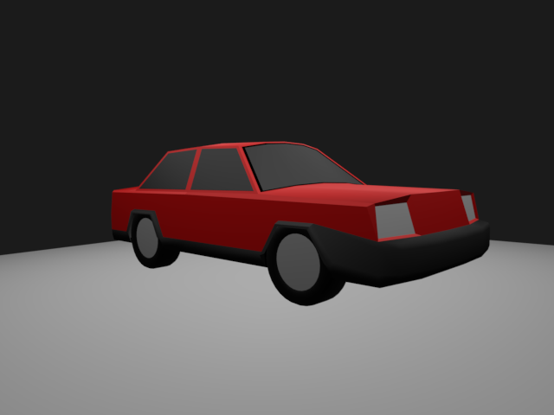

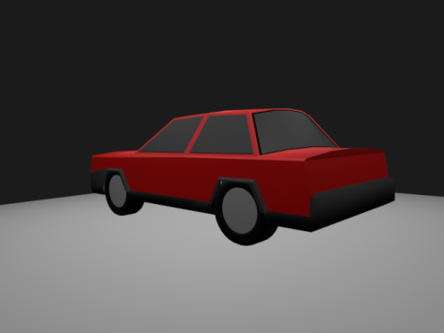

Link for the blender files and Rendered Images:
https://drive.google.com/drive/folders/1gn8jf23otG3q2guqTqu_dEoAsUp7hiID

